2014 Lead Line Dressage Test B

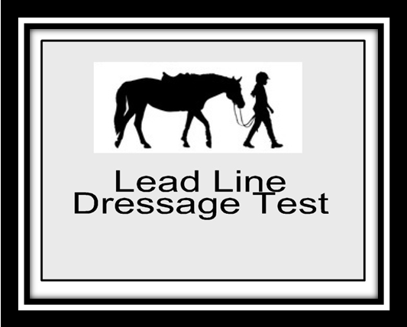
PURPOSE: To introduce riders to the dressage arena and to have FUN!
Requirements: Medium Walk
8 – 10 Meter Circle

Test Directive Ideas Remarks
A  X  C | Enter down center line at the walk  Halt Salute. Proceed at the walk  Turn Left at the walk | Straightness on Center Line  Balance of turn | 10
H B | Change – Short Diagonal at the walk | Steadiness of Walk | 10
F | Circle right 8 – 10 meter | Circle Shape | 10
K B | Change – Short Diagonal at the walk | Steadiness of Walk | 10
M | Circle left 8 – 10 meter | Circle Shape | 10
Btw H and K | Develop Rising Trot | Steadiness of Trot | 10
K | Walk | Quality – Transition | 10
A  X | Down Center line at the walk  Halt Salute | Straightness on center line | 10
Leave arena in walk exit at A
Rider Marks
Position of Rider | 10
Use of Aids, Independence from leader | 10 | 2

Subtotal
Errors | ( )
Total Points
Further Remarks

